**Flutter Project Setup Instruction**

**For**

**Plant Diagnosis System**

# **System Requirements**

Development environment must meet following minimum requirements:

1. **Operating Systems**: Windows 7 SP1 or later (64-bit)
2. **Disk Space**: 400 MB (does not include disk space for IDE/tools).
3. **Tools**:
4. [Windows PowerShell 5.0](https://docs.microsoft.com/en-us/powershell/scripting/install/installing-windows-powershell) or newer (this is pre-installed with Windows 10)
5. [Git for Windows](https://git-scm.com/download/win) 2.x, with the **Use Git from the Windows Command Prompt** option.

If Git for Windows is already installed, make sure it can be run git commands from the command prompt or PowerShell.

**Download Flutter SDK**

Download latest stable released installation bundle of the Flutter SDK from:

<https://flutter.dev/docs/get-started/install/windows>

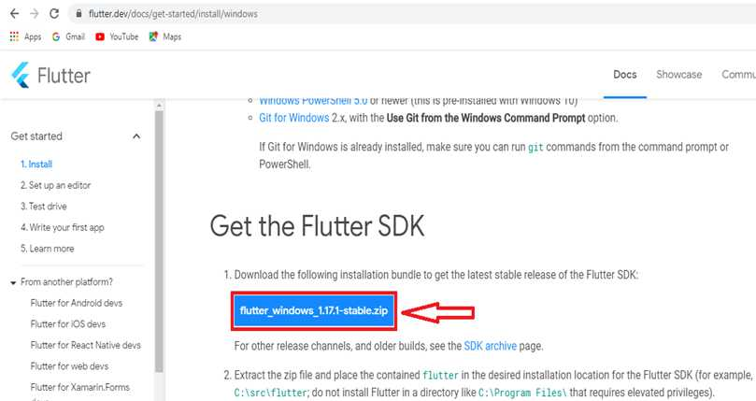

Extract the zip file.

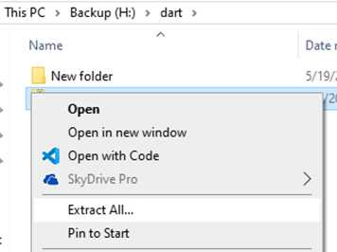

1. Place the contained flutter in the desired installation location for the Flutter SDK in “**C:\src”** or

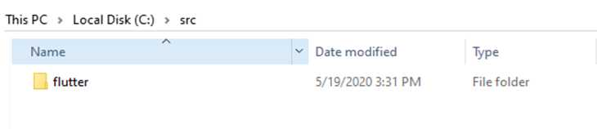

**Note:** Do not install Flutter in a directory like “C:\Program Files\” that requires elevated privileges.

# **Update Path of Environment Variable**

1. Go to **Windows Search** and write **‘env’**. Click on the ‘open’ option on right.

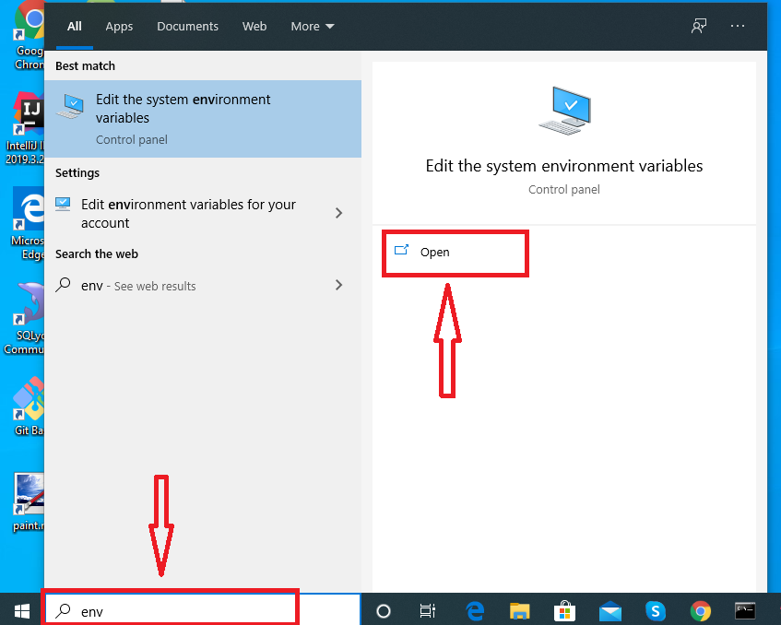

1. Following **System Properties** window will be open. Click on **Environment Variables**.

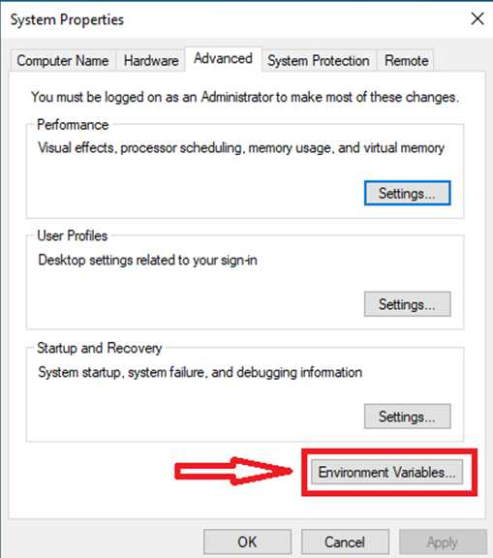

1. Under **User variables** check if there is an entry called **Path**.
2. If the entry exists, add the full path to ‘**C:\src\flutter\bin’** using**“ ; ”** as a separator from existing values.

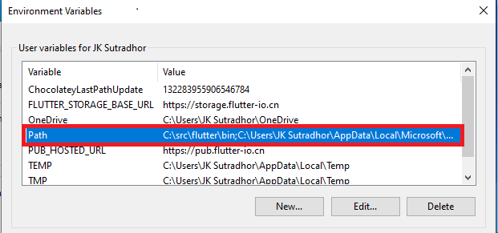

1. Then click **OK** to exit from **System Properties** window.

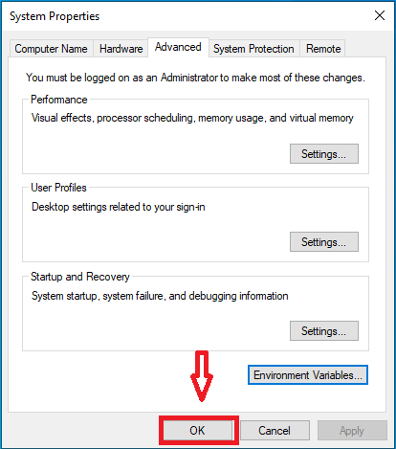

1. If the entry doesn’t exist, create a new user variable named **Path** with the full path to **‘C:\src\flutter\bin’** as its value. Then click **Ok**.

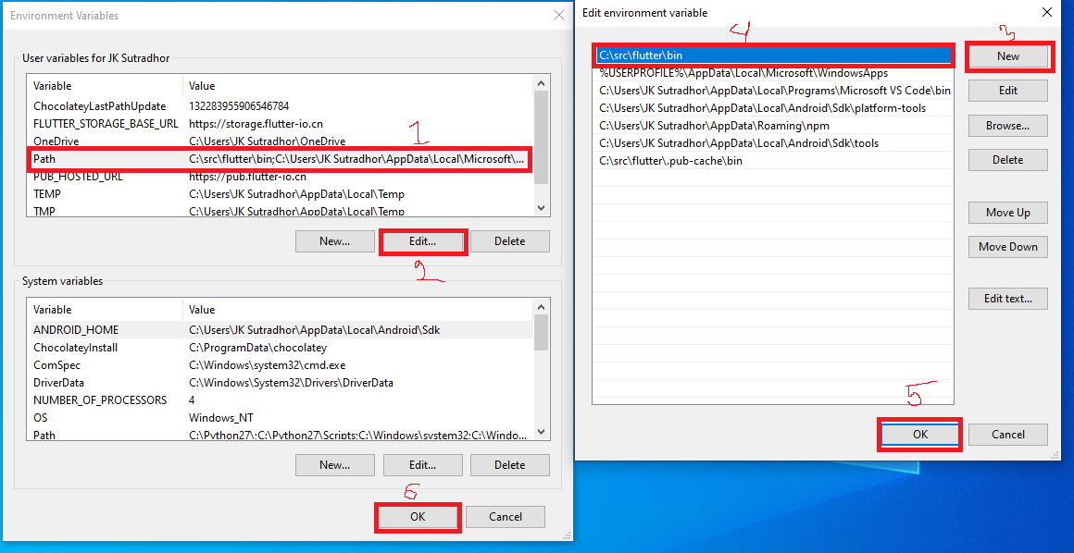

# **Run Flutter Doctor**

1. Go to “**C:\src\flutter**” and double click on **‘flutter_console’** .

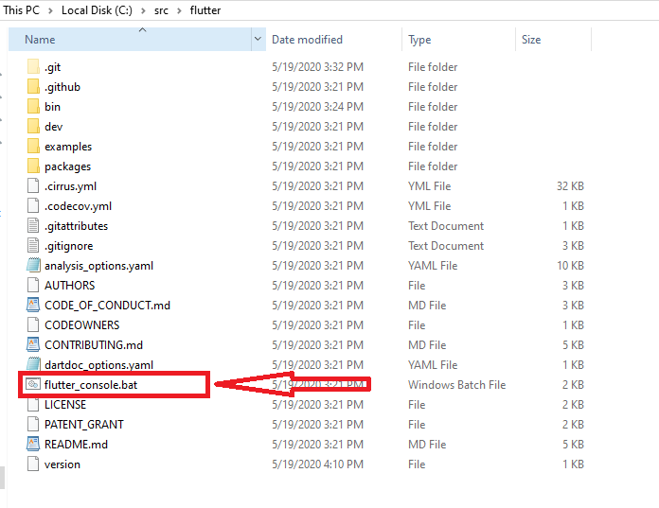

1. Command prompt window will be open. Type type flutter doctor and press Enter.

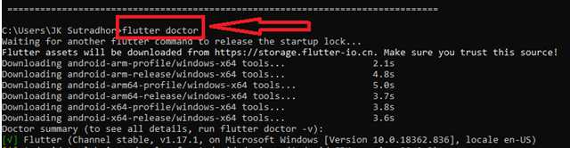

1. Type **flutter upgrade** and press **Enter**

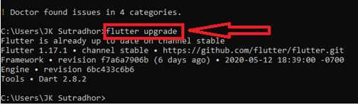

This command checks the environment and displays a report of the status of Flutter installation. Check the output carefully for other software you might need to install or further tasks to perform (shown in **bold** text).

# **Android Setup: Install Android Studio**

1. Download and install from: <https://developer.android.com/studio>

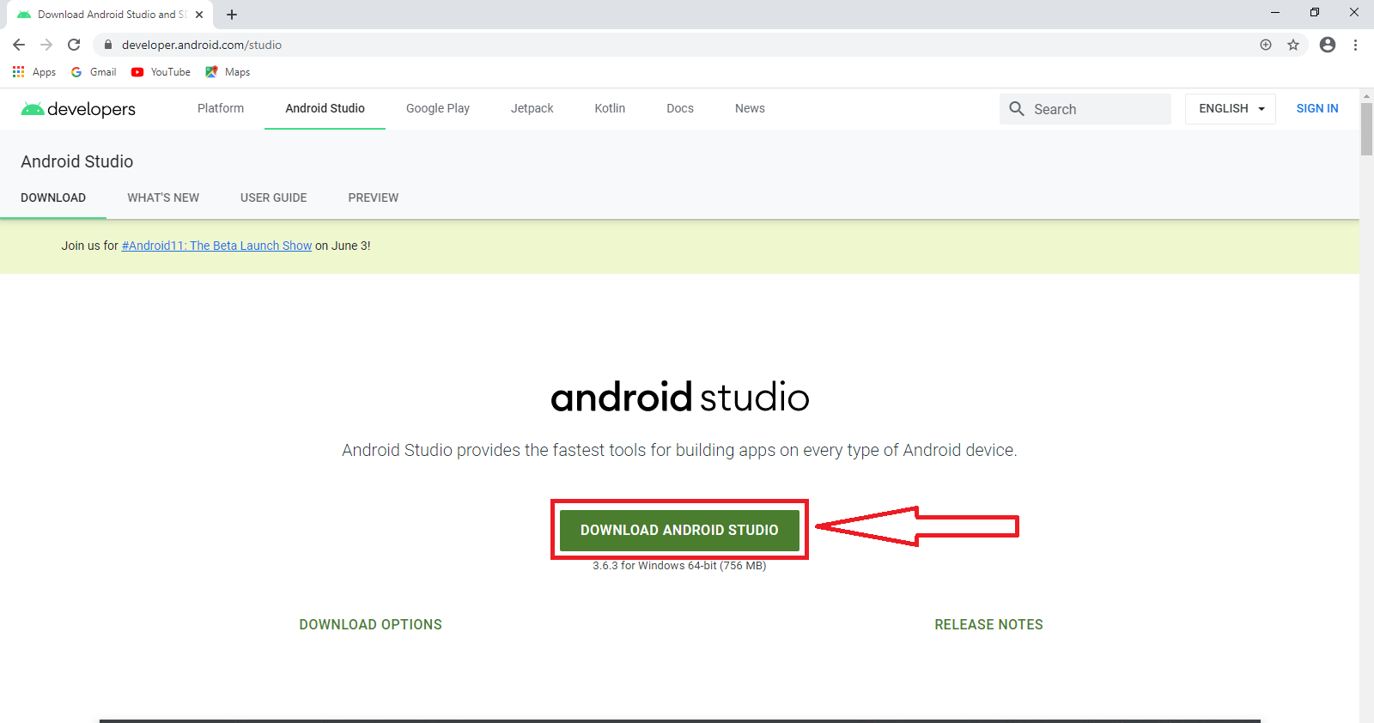

1. Start Android Studio, and go through the ‘**Android Studio Setup Wizard**’.

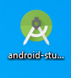

1. This installs the latest Android SDK, Android SDK Command-line Tools, and Android SDK Build-Tools, which are required by Flutter when developing for Android.

**Warning:** In Android Studio 3.6 or later, it needs to manually add the old version of the Android SDK Tools for Flutter to work. To do this:

* Open the **Android Studio SDK Manager**
* In the Android SDK tab, uncheck **Hide Obsolete Packages**
* Check **Android SDK Tools (Obsolete)**

The image below shows the appropriate settings:

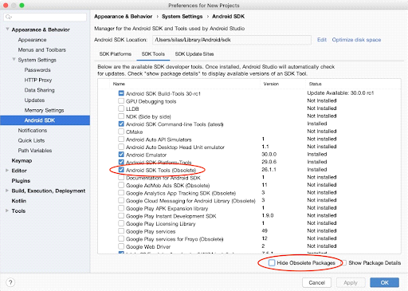

This is a [**known issue**](https://github.com/flutter/flutter/issues/51712) that will be addressed in an upcoming version of Flutter.

# **Set up Android Device:**

To run and test Flutter app on an Android device, It needs an Android device running **Android 4.1** (API level 16) or higher.

1. Enable **Developer options:**  go to **“Settings > About Phone”**

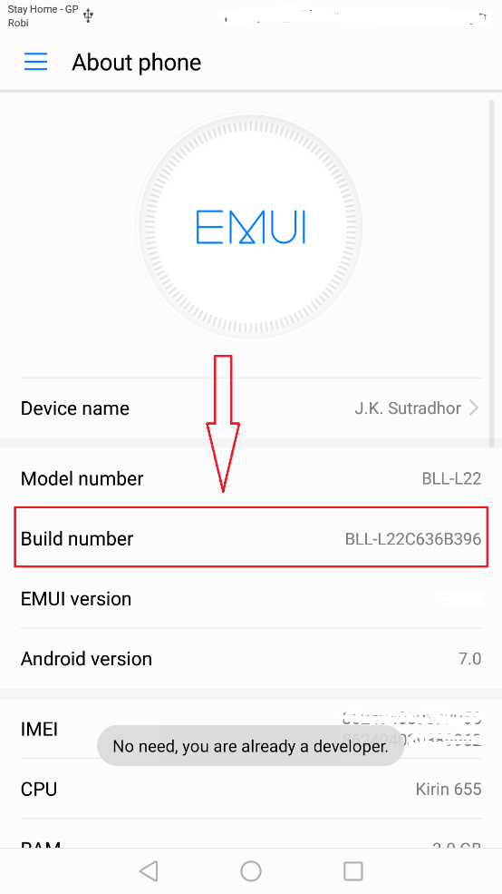

1. Tap 5-7 times continues on **‘Build Number’** (It will enable developer option for Project Run)
2. After tapping, it will show a toast **‘You are in developer mode’**.  
   If you did this already, you will get the toast **‘No need, you are already a developer’** .
3. Again, Go to “**Settings > Developer Option”**
4. Enable **USB debugging** on your device. Tap on the **‘USB debugging’** to enable it.
5. And If the alert dialogue is opened then simply click on the marked ‘OK’ button

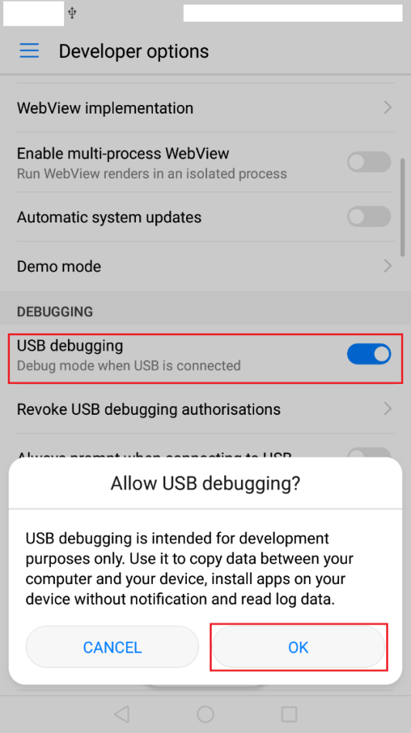

1. Using an USB cable, plug the phone into the computer. If prompted on the device, authorize the computer to access that device by click on the marked ‘OK’ button.

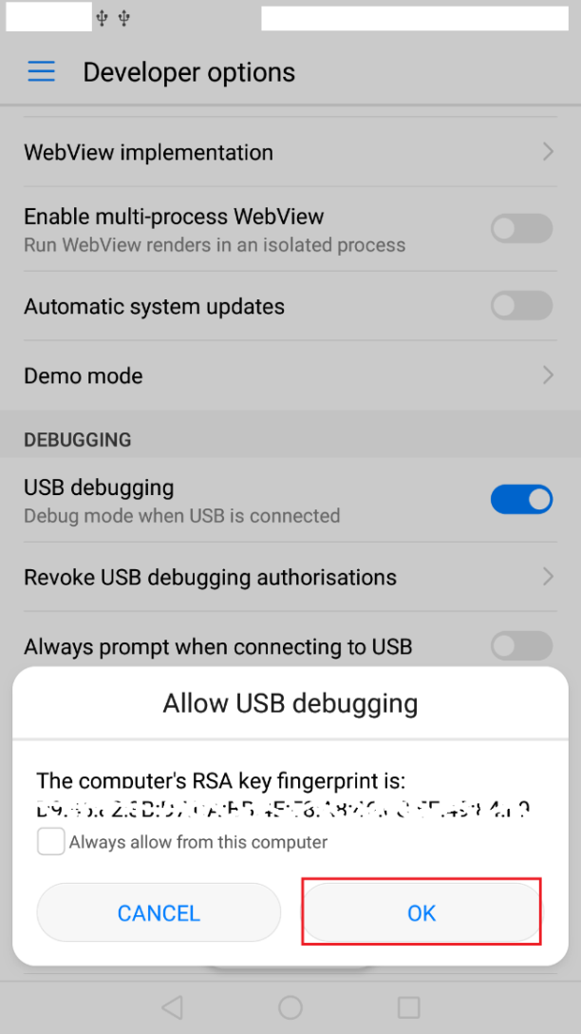

**Windows-only,** Install the[**Google USB Driver**](https://developer.android.com/studio/run/win-usb) if it fails to detect automatically. Help guide is available in- <https://developer.android.com/studio/run/win-usb>

1. In the terminal, run the **flutter devices** command to verify that Flutter recognizes the connected Android device.

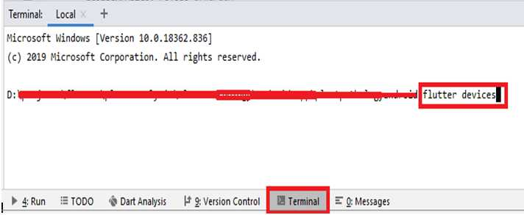

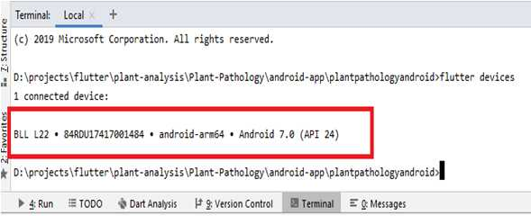

1. Set **ANDROID_HOME** environment variable by showing the Android SDK path.

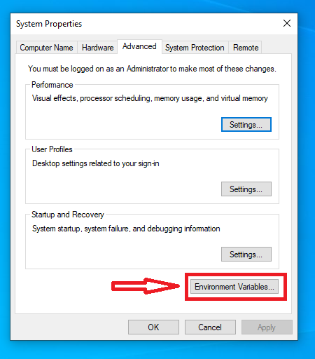

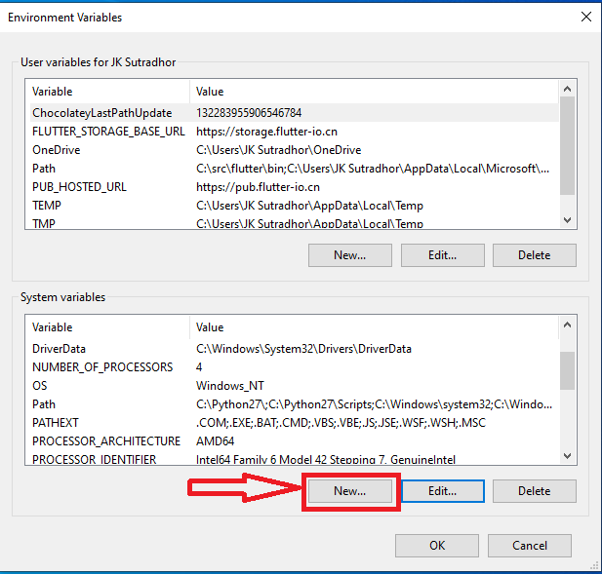

* 1. Variable name: **ADROID_HOME**
  2. Variable value: “Location of Android Sdk” then press ‘OK’

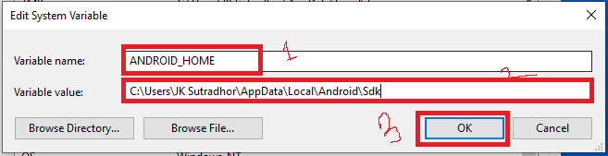

* 1. Exit form Environment by **OK**.

# **Set up the Android Emulator:**

To prepare to run and test Flutter app on the Android emulator, follow these steps:

* Enable [VM acceleration](https://developer.android.com/studio/run/emulator-acceleration) on your machine.

1. Start Android Emulator.
2. Click on the marked Icon as below image



1. Click on the **Create Virtual Device**

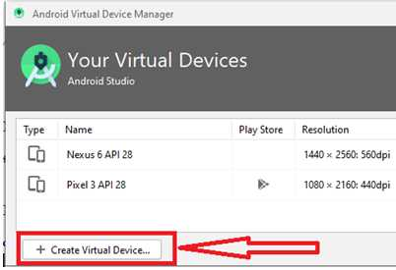

Or, Launch **Android Studio > Tools > Android > AVD Manager** and select “**Create Virtual Device”**. (The **Android** submenu is only present when inside an Android project.)

1. Choose a device definition and select **Next**.

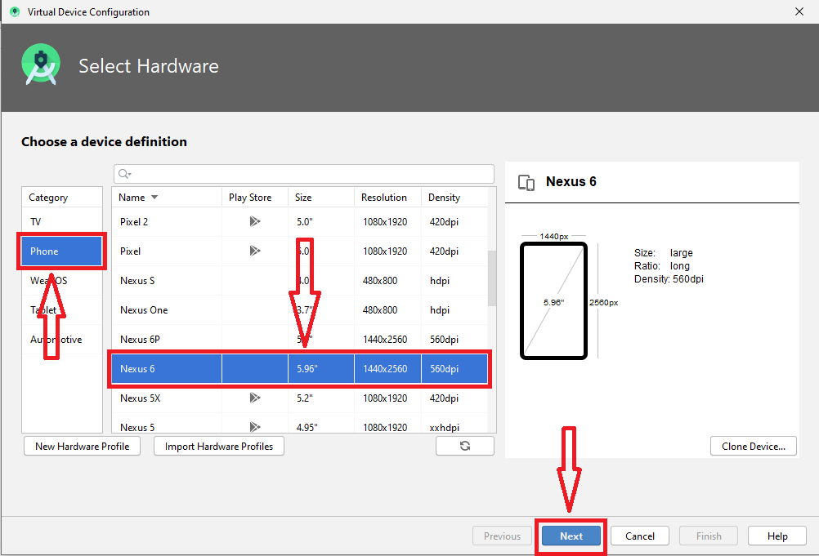

1. Select one or more system images for the Android versions, and select **Next**. An *x86* or *x86_64* image is recommended.

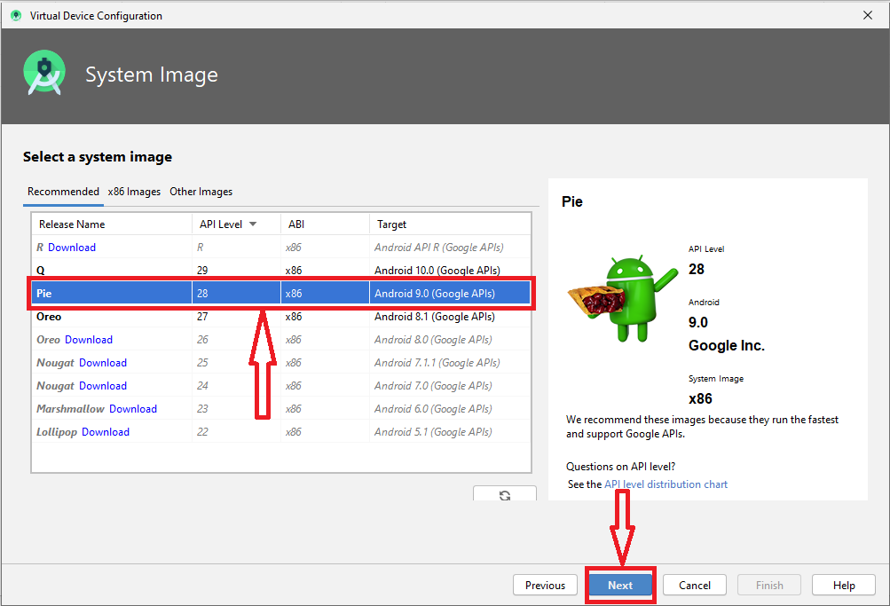

1. Under Emulated Performance, select **Hardware - GLES 2.0**. Verify the AVD configuration is correct, and select **Finish**.

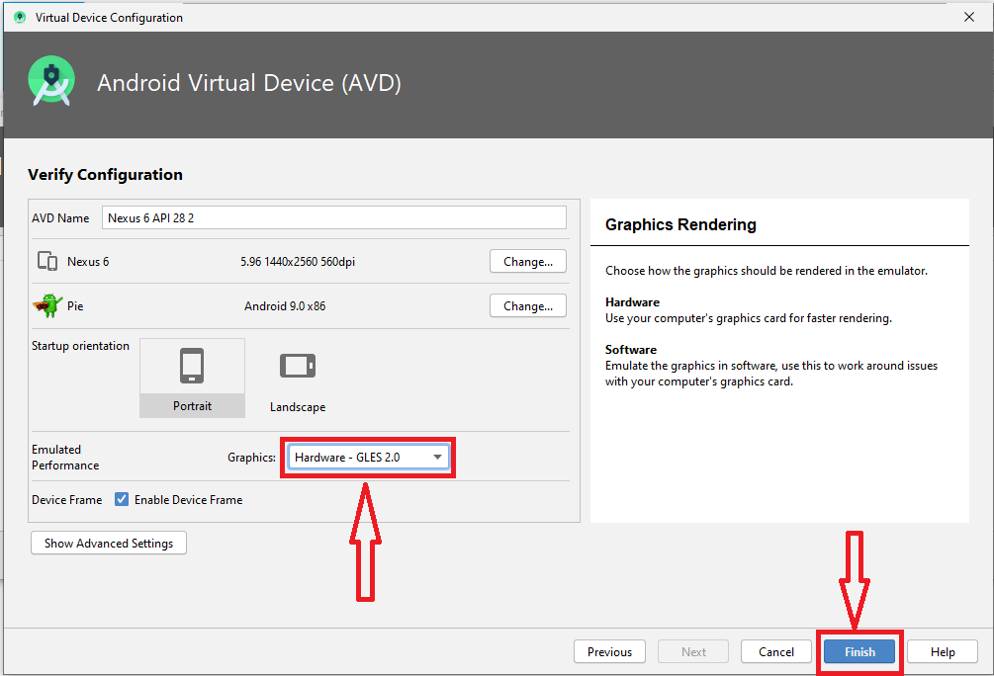

1. In Android Virtual Device Manager, click **Run** from the toolbar.

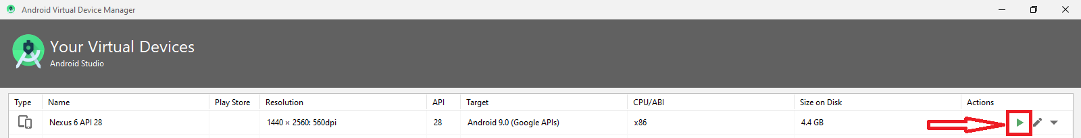

1. The emulator starts up and displays the default canvas for selected OS version and device.

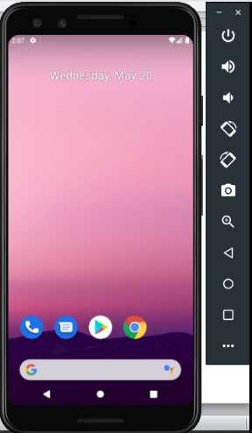

# **Running Project in the Emulator:**

1. Check out the project from Git.
2. Open the project in android studio marked menu.

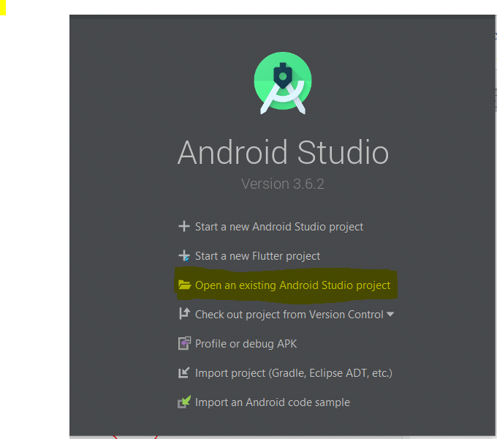

1. Select the project folder which is downloaded from Git Repository.
2. Download all dependencies by clicking **Get dependencies**



1. Click (**<no devices>**)-highlighted in below image, and select device/emulator.



1. Click on the **Run icon** to run the project in the device/emulator (shown in the image given below).

